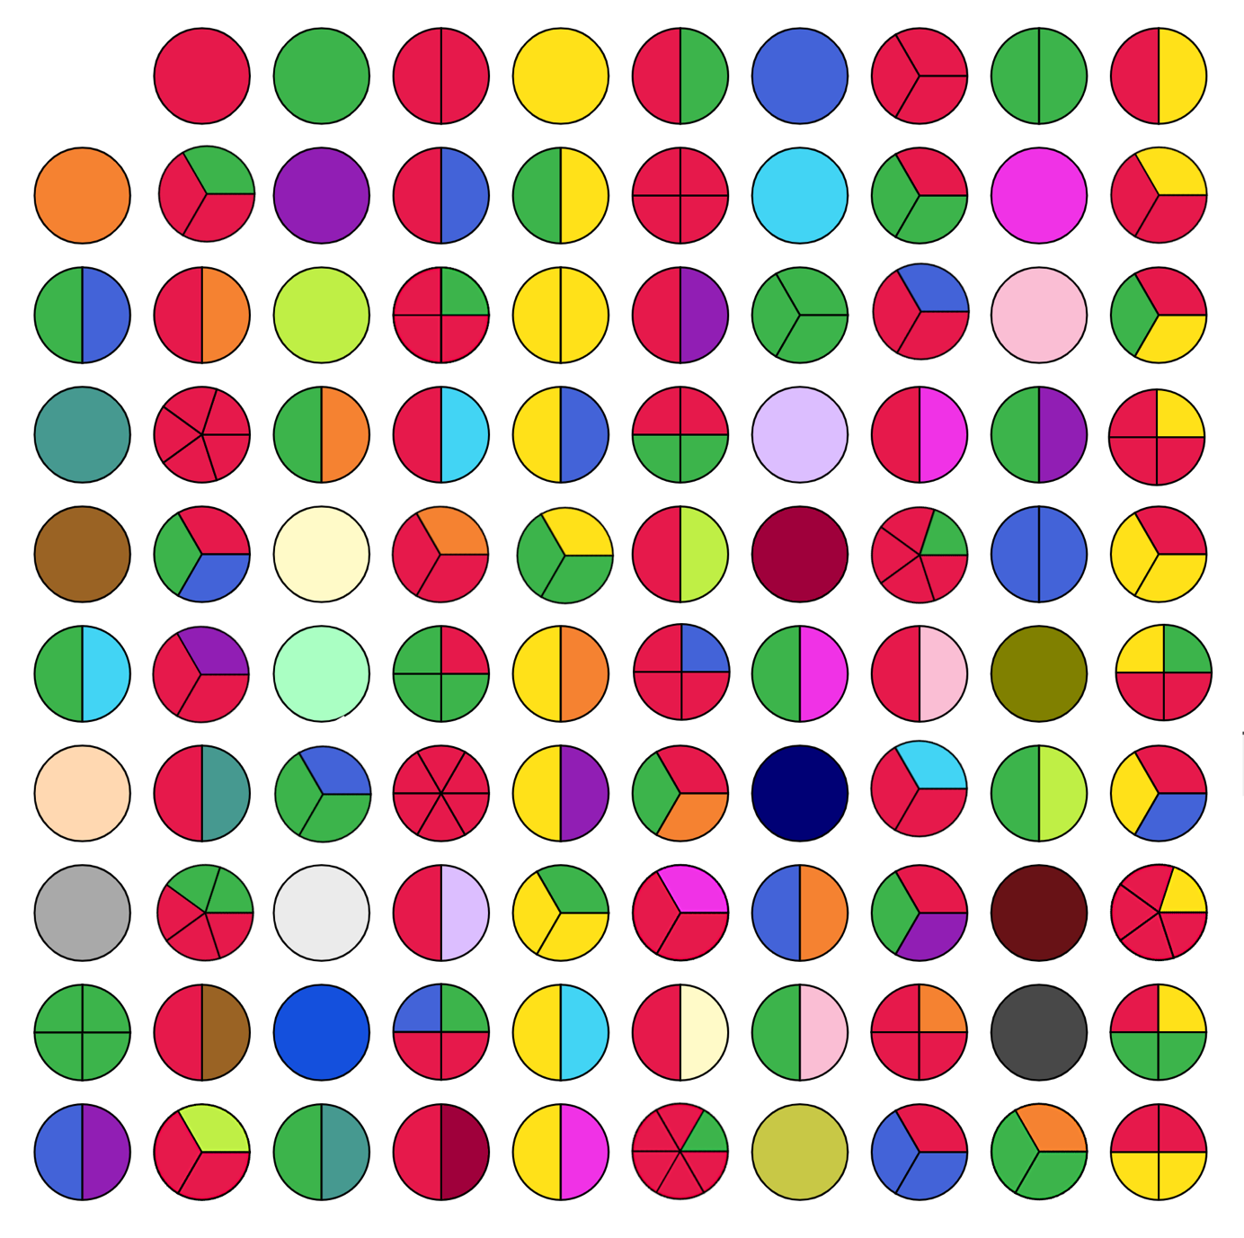
What do you notice?

Here are some questions you may like to consider:
What is special about the circles that are not split up?
Can you explain what is happening in the top row?
What do you notice about the colours in the fifth column?
What is happening in the far right column?
Take a look at the colours of the first two circles (2 and 3).
What is special about the circles/numbers that have these two colours?
What is special about the circles/numbers that have only these two colours?
Why do multiples of 11 appear on a diagonal line?
Why do multiples of 9 appear on a diagonal line?
Look at the circle that represents 8. The three parts are all the same colour.
How many other circles/numbers will also be split into three identical colours?
On the bottom row, 93, 94 and 95 appear as three consecutive circles/numbers, each split into two, and no colour is repeated.
Can you find a similar set of four consecutive circles/numbers where no colour is repeated? If not, why not?
What other patterns can you see? Can you explain why they occur?

